1. Prepare a USB flash drive, format --- select the format, change the file system format to NTFS, volume label to WINPE.

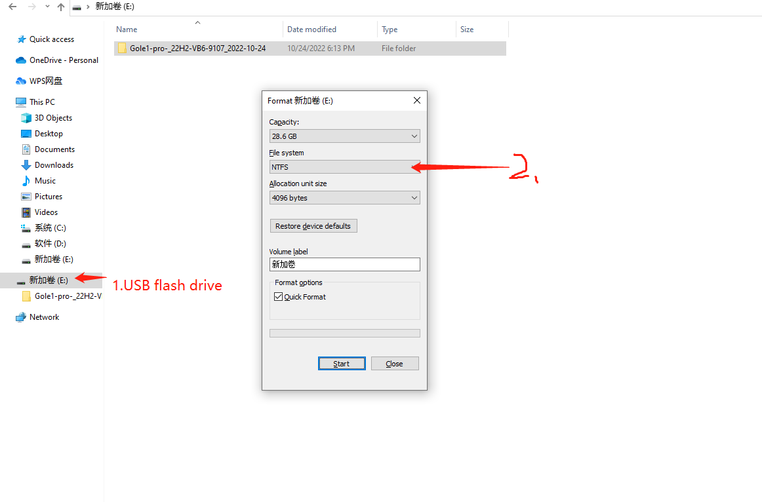

2.Save the data on a USB flash drive and decompress it.A total of 12 files.

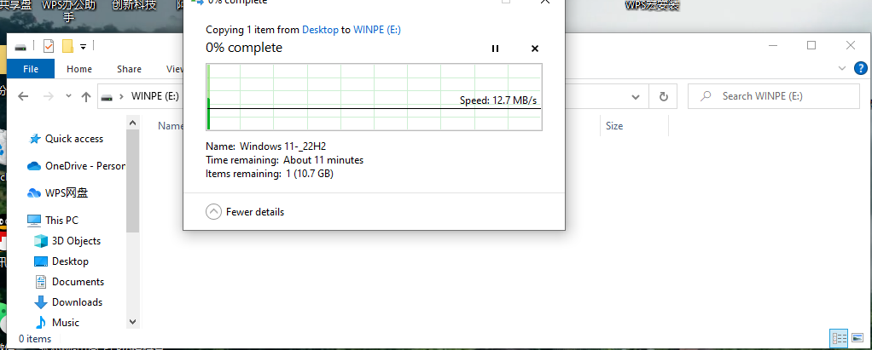

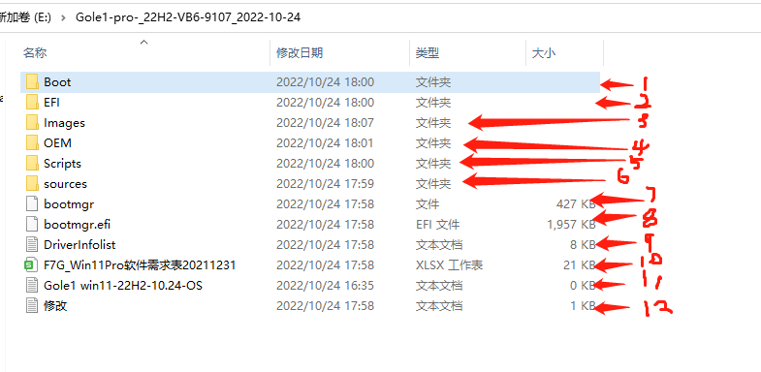

3.Insert the memory card into the gole 1 Pro, turn on the computer, and press the F7 button continuously.

Appears: Options beginning with UEFI, select one

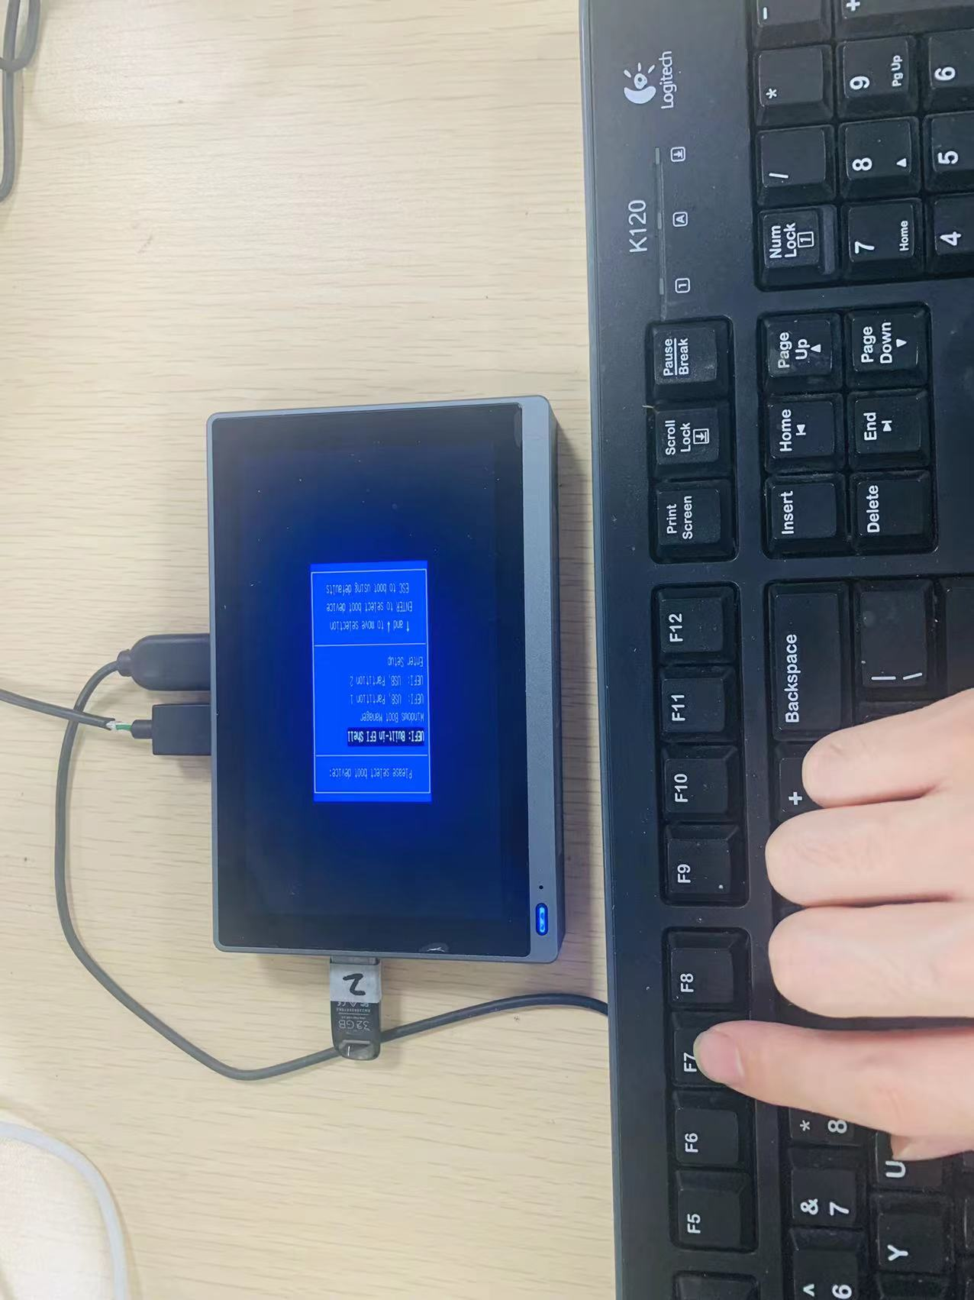

4.Appears: Options beginning with UEFI, select one

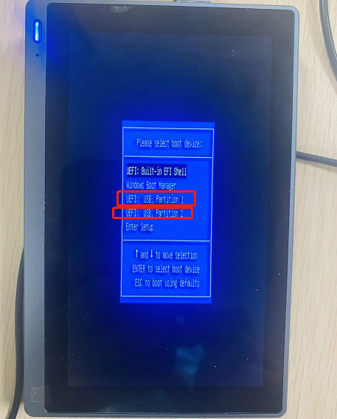

5.Wait a moment, choose the right one is this page will appear

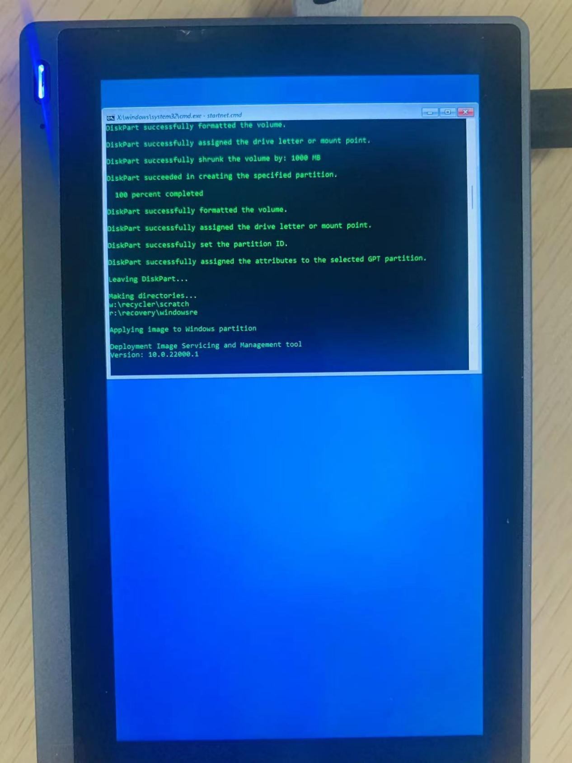

1. Probably need to wait a while

7.Wait a moment, The correct GOLE 1 PRO enters the interface.

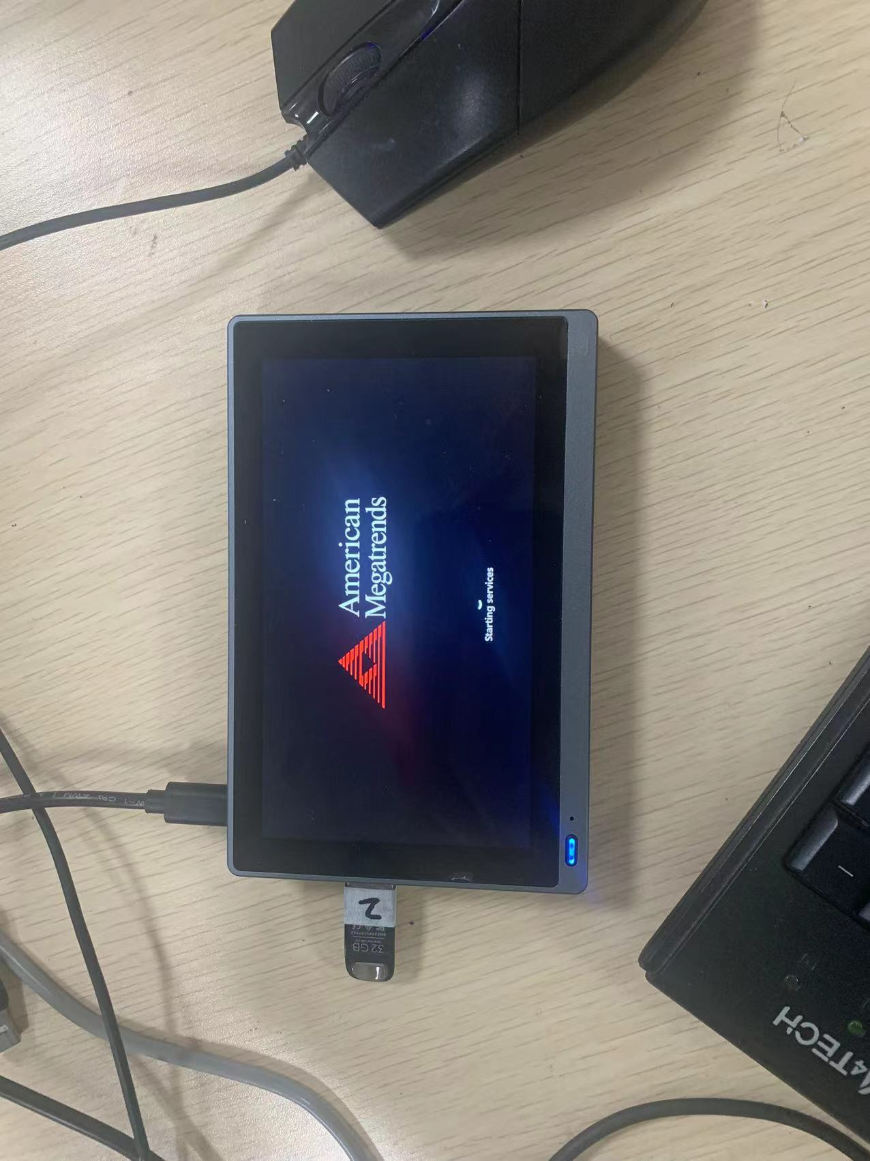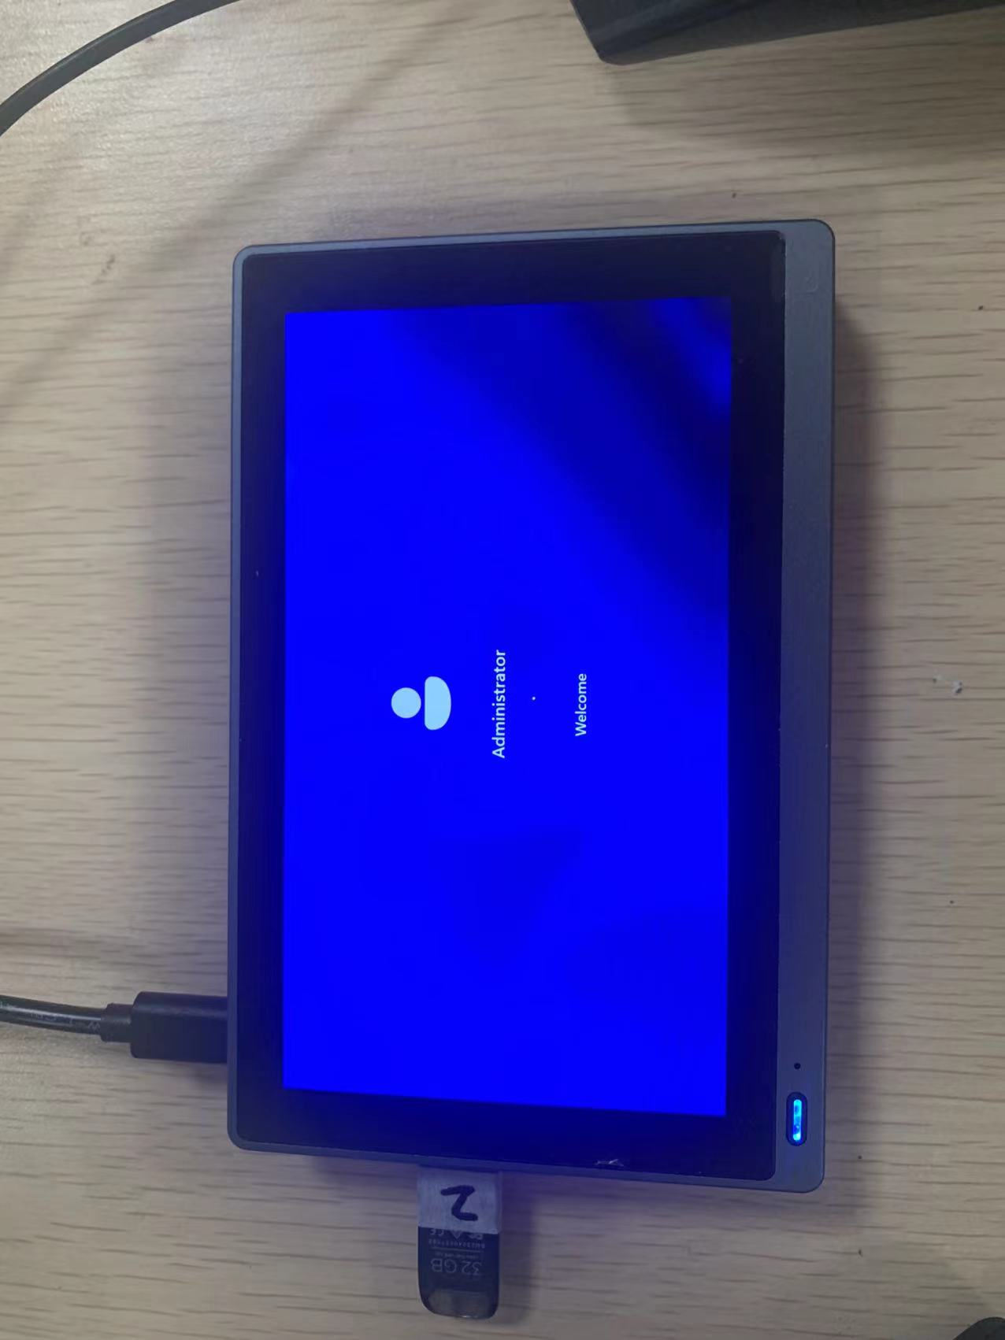

8.Enter the system, click OK, even if it is finished, enter the user system

